**5.1 CPU architecture**

**Name ___________ class_____________**

1. What are the features of Von Neumann Architecture

____________________________________________________________________________________________________________________________________________________________________________________________________________________________________________________________________________________

1. The function of CU

______________________________________________________________________________________________________________________________________________________________________________________________________________

1. The function of ALU

______________________________________________________________________________________________________________________________________________________________________________________________________________

1. A processor has just one general-purpose register. Give the name of this register.

_____________________________________________________________________

1. State the role of each of the following special purpose registers used in a typical processor.
2. PC

_________________________________________________________________________________________________________________________________________

1. MAR

_________________________________________________________________________________________________________________________________________

1. MDR

_________________________________________________________________________________________________________________________________________

1. CIR

_________________________________________________________________________________________________________________________________________

1. IX

_________________________________________________________________________________________________________________________________________

1. SR

_________________________________________________________________________________________________________________________________________

1. What does 3MHz mean

_________________________________________________________________________________________________________________________________________

1. The processor uses buses in the FE cycle. The diagram shows three buses and two descriptions. Draw one line from each bus to its appropriate description.

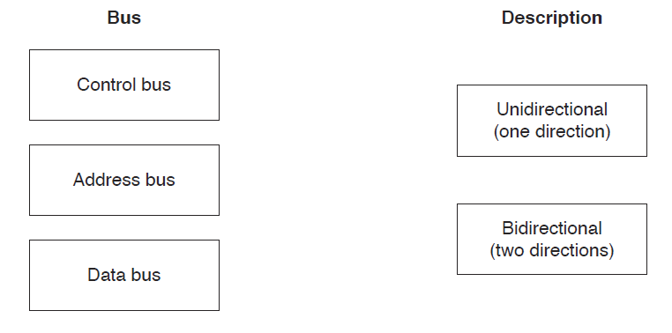

1. (a) The diagram shows the components and buses found inside a typical Personal Computer (PC).

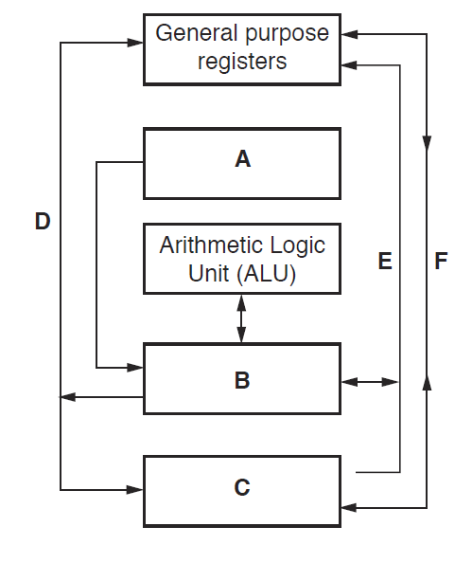



Some components and buses only have labels A to F to identify them.

For each label, choose the appropriate title from the following list. The title for label D is

already given.

• Control bus

• System clock

• Data bus

• Control unit

• Main memory

• Secondary storage

Ans:

**A – System clock**

B – **Control unit**

**C – Main memory**

**D Address bus**

**E – Control bus**

**F – Data bus**

(b) Clock speed is a factor that affects the performance of a PC. Explain this statement.

* + 1 The model has the following basic features:
    - There is a **processor**, a central processing unit.
    - The processor has direct access to a **memory**.
    - The memory contains a '**stored program**'  and the data required by the program.
    - The stored program consists of individual **instructions**.
    - The processor executes instructions sequentially.
* 2 The Control Unit of a computer system controls the operations of components like ALU, memory and input/output devices.
  + 3 Arithmetic Logic Unit (ALU)
    - performs calculations on data
      * arithmetic operations
      * logical operations
      * Comparisons

4 accumulator.

5 (a) PC: This register contains the address of the next instruction to be executed.

(b) MAR: MAR holds the memory address of data that needs to be accessed.

(c) data or program instruction is to be read from or written to memory, their values are temporarily stored in the memory data register (MDR)

(d) •CIR is a register that stores the instructions currently waiting to be executed by CPU.

(e) •Stores a value only used for indexed addressing mode. The actual address of the variable = variable initial address + index register value

(f) •Each bit of the status register indicates whether a different event has occurred.

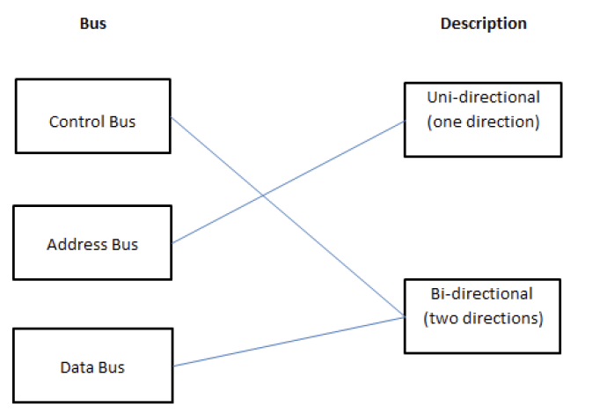

A – System clock

B – Control unit

C – Main memory

E – Control bus

F – Data bus

1 Mark per bullet, max 2

• The clock sends out a number of pulses in a given time interval (clock speed)

• Each processor instruction takes a certain number of clock cycles to execute

• The higher the clock frequency, the shorter the execution time for the instruction

// Increasing the clock frequency improves performance